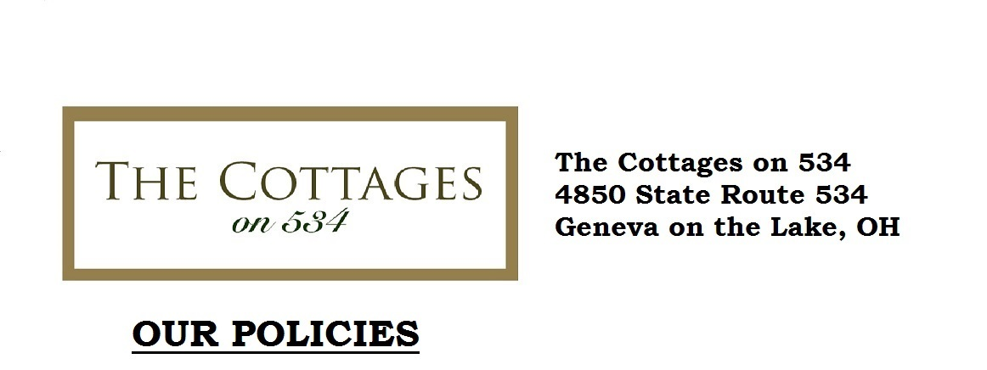

A $200.00 reservation deposit is required to hold reservations. The deposit guarantees your reservation and will be returned in-full at the end of your stay, provided there are no damages to the cottage during your stay.
The rental fee itself must be paid in full 14 days prior to your stay or the reservation deposit will be forfeited. We accept Master Card, Visa and Personal Checks.
For cancellations made 14 days or more before a non-holiday arrival, we will refund the reservation deposit less a $50 booking fee. For cancellations made less than 14 days prior to arrival, the rental fee is non-refundable. If we can rebook your cancelled reservation, a refund may be made at the discretion of Management.
Check-in time is 3:30 PM. Check-out time is 11:00 AM.
Pricing does not include sales tax, bed tax, and a $30 cleaning fee.
There is a strict no smoking policy in any Cottage for both guest safety and in accordance with Ohio State Law. If we find evidence of smoking inside the property the reservation deposit will be forfeited.
There are no pets allowed in our cottages. Evidence of pets being kept in the Cottages will result in forfeiture of the reservation deposit.
From May through October, a two-night minimum is required for all weekend rentals.
At the end of your stay, we ask that you please remove all trash and place it in the outdoor trash receptacles, wash all dishes, glassware, pots, and pans, clean coffee pots, stove top, microwave, and countertops. Please place all used towels, washcloths, and dish towels in the laundry basket provided. Please be respectful and leave the Cottage in the same general condition that you found it!
Renters shall hereby indemnify and hold harmless the owner against any claims of personal injury or property damage or loss arising from use of the premises regardless of the nature of the accident, injury or loss. Renters expressly recognize that any insurance for property damage or loss which the owner may maintain on the property does not cover the personal property of renters.
The Cottages are privately owned; the owners of the property (“Owners”) are not responsible for any accidents, injuries or illness that occur while on the rental premises. The Owners are not responsible for the loss of personal belongings or valuables of guests. By reserving The Cottages, you agree to release Owners and agree to indemnify them against, and hold them harmless from and against, any and all injuries, liability, claims, demands, causes of action, costs to or by you, or to any other person you bring onto the rental premises, that arise from or are in any way related to or in connection with, directly or indirectly, your rental or use of the property.

